**CY 525 Network and Wireless Security**

**HOP01 – Installing Kali Linux**

6/4/2020 Developed by Clark Ngo

10/10/2020 Reviewed by Spencer (Yu Che) Liu

4/1/2022 Reviewed by Wenzhi Xu

08/16/2023 Reviewed by Vaishnavi Mandage

Center for Information Assurance (CIAE) @City University of Seattle (CityU)

**Before You Start**

• Version numbers may not match with the most current version at the time of writing. If given the option to choose between stable release (long-term support) or most recent, please choose the stable release rather than beta-testing version.

• This tutorial targets Windows users and MacOS users.

• There might be subtle discrepancies along the steps. Please use your best judgement while going through this cookbook style tutorial to complete each step.

• For your working directory, use your course number. This tutorial may use a different course number as an example.

• The directory path shown in screenshots may be different from yours.

• If you are not sure what to do or confused with any steps:

1. Consult the resources listed below.

2. If you cannot solve the problem after a few tries, ask a TA for help.

**Learning Outcomes**

Students will be able to:

• Install Kali Linux

**Resources**

• Kali Linux (Official Website) – <https://www.kali.org/>

• Kali Linux Revealed - <https://kali.training/downloads/Kali-Linux-Revealed-1st-edition.pdf>

## What is Kali Linux?

[Kali Linux](https://www.kali.org/) is a Debian-based Linux distribution aimed at advanced Penetration Testing and Security Auditing. Kali contains several hundred tools which are geared towards various information security tasks, such as Penetration Testing, Security research, Computer Forensics and Reverse Engineering. Kali Linux is developed, funded and maintained by [Offensive Security](https://www.offensive-security.com/), a leading information security training company.

Kali Linux was released on the 13th of March 2013 as a complete, top-to-bottom rebuild of [BackTrack Linux](https://www.backtrack-linux.org/), adhering completely to [Debian](http://www.debian.org/) development standards.

Source: <https://www.kali.org/docs/introduction/what-is-kali-linux/>

## The Setup

We need the following:

* **Host Operating System (Host OS).** Host OS can be Windows OS, MacOS, or Linux OS.
* **Hypervisor.** Creates and runs virtual machines. VirtualBox and VMware are examples. We will be using VirtualBox.
* **Guest OS.** We can install any operating system we want. We will use Kali Linux.

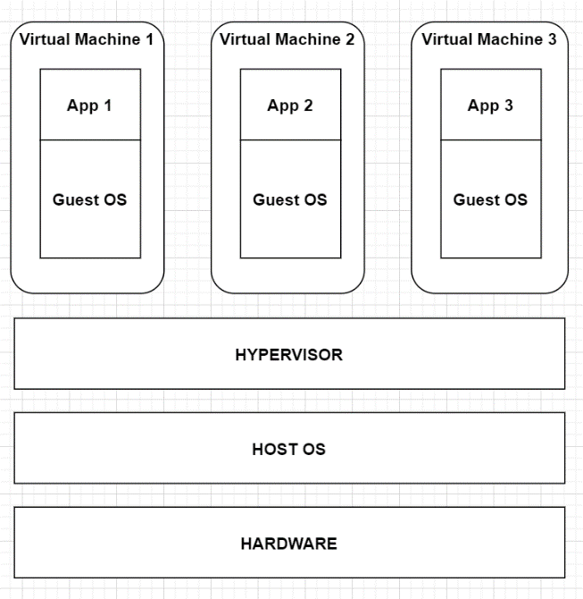 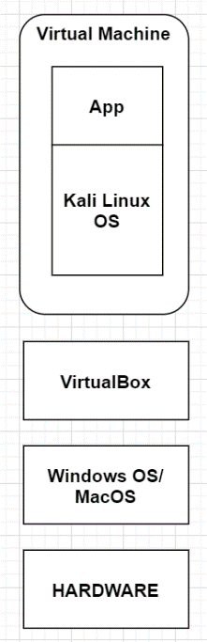

## What is VirtualBox?

*A virtualization software product*

VirtualBox is a general-purpose virtualization tool for x86 and x86-64 hardware, targeted at server, desktop, and embedded use, that allows users and administrators to easily run multiple guest operating systems on a single host.

* **Why does VirtualBox matter?** VirtualBox makes it possible for administrators and developers to quickly spin up full-blown operating systems without having to use dedicated hardware, thereby saving precious budget dollars on hardware.
* **Who does VirtualBox affect?** VirtualBox affects anyone who needs to easily deploy a VM to be used as a server, desktop, testing environment, or teaching tool.

Source: <https://www.techrepublic.com/article/virtualbox-everything-the-pros-need-to-know/>

What is Hypervisor?

*The technology term for VirtualBox or VMware*

A hypervisor is computer software, firmware or hardware that creates and runs virtual machines. A computer on which a hypervisor runs one or more virtual machines is called a host machine, and each virtual machine is called a guest machine. [Wikipedia](https://en.wikipedia.org/wiki/Hypervisor)

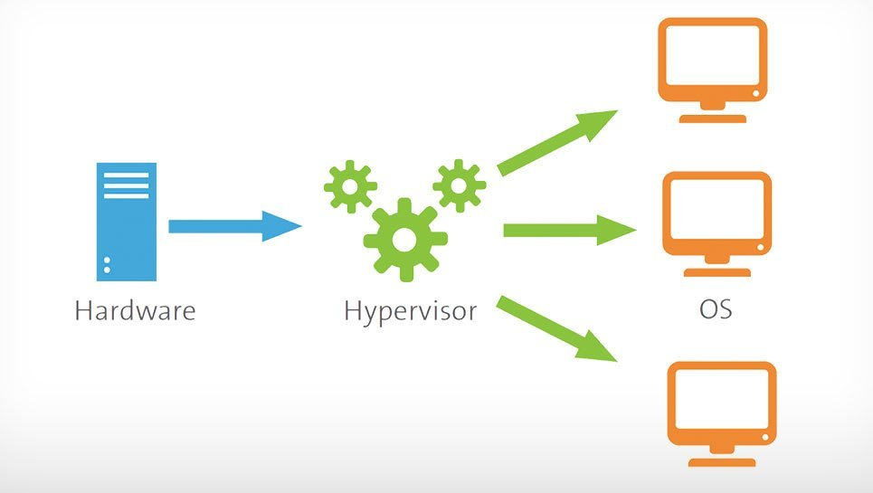

Source: <https://www.vmware.com/topics/glossary/content/hypervisor>

# What is Virtualization? (2 minutes 51 seconds)

*Creating virtual computer hardware platforms*

Source: <https://youtu.be/iBI31dmqSX0>

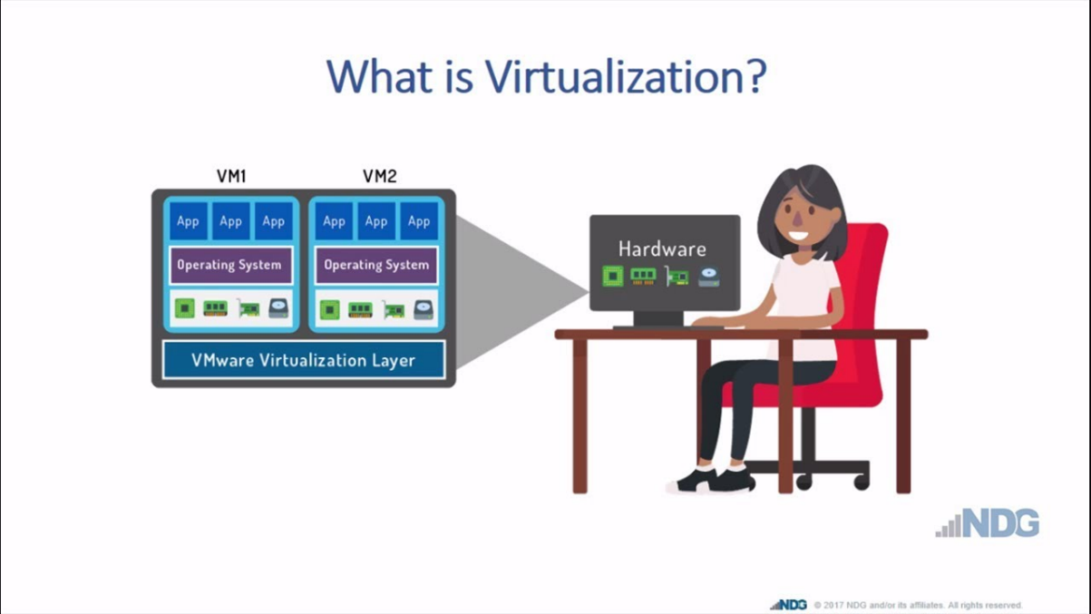

# Traditional Architecture vs Virtual Architecture

*Without a hypervisor (virtualization layer) vs with a hypervisor (virtualization layer)*

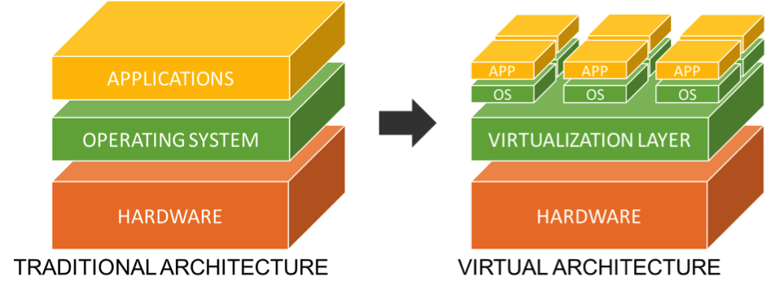

Source: <https://resources.infosecinstitute.com/11-points-consider-virtualizing-security/>

Installing Virtual Box in Windows OS - <https://youtu.be/2TkM4M10fvU>

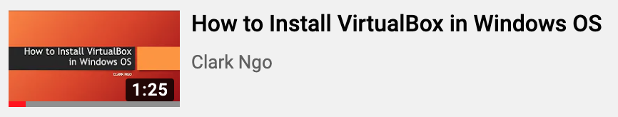

Installing Virtual Box in MacOS - <https://youtu.be/ZJRnknEhRVs>

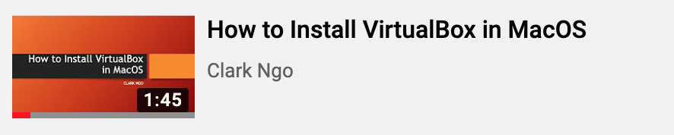

Installing Kali Linux using Virtual Box - <https://youtu.be/2Fjl6P84s64>



Steps:

1. Download Kali Linux ISO: [https://www.kali.org/downloads/](https://www.youtube.com/redirect?v=2Fjl6P84s64&redir_token=BxCcMytEBFnHjfVqa2o6WuxrX_58MTU5MTgzNzE0MEAxNTkxNzUwNzQw&event=video_description&q=https%3A%2F%2Fwww.kali.org%2Fdownloads%2F)

2. Open VirtualBox Application

3. Add a new operating system - 1 GB Memory - 20 GB File Size

4. Go through the installation

SHOW LESS